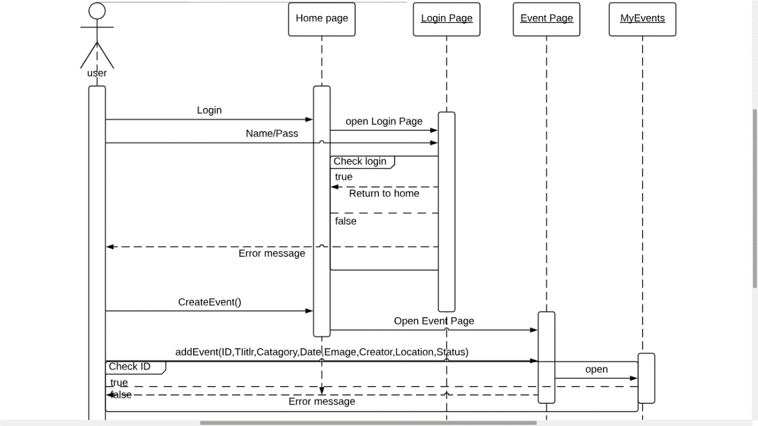Case 1: a registered user making an event

Case 2 : a visitor adding a wish

